AD-HTC Digital Twin: Integrated Anaerobic Digestion – Hydrothermal Carbonization Power Plant Simulation

TABLE OF CONTENTS
- ABSTRACT
- INTRODUCTION
- OBJECTIVES
- THEORETICAL BACKGROUND
- EFFICIENCY EQUATIONS
- ENERGY BALANCE PRINCIPLES
- METHODOLOGY
- IDEAL GAS ASSUMPTIONS
- TURBINE EFFICIENCY MODELING
- PRESSURE AND TEMPERATURE INPUTS
- SYSTEM INPUTS
- RESULTS
- DISCUSSION
- LIMITATIONS
- CONCLUSION

ABSTRACT
This laboratory project presents the development and analysis of a digital twin for an integrated Anaerobic Digestion–Hydrothermal Carbonization (AD-HTC) power generation system. The model combines a Rankine steam cycle and a Brayton gas cycle with integrated energy recovery to improve overall system efficiency. Anaerobic digestion produces methane-rich biogas, which serves as the primary fuel for the Brayton cycle, while waste heat from the gas turbine exhaust is recovered to supply thermal energy for steam generation in the Rankine cycle. Thermodynamic simulations were conducted under steady-state conditions using idealized assumptions to evaluate cycle efficiencies, power output, and energy utilization. Key performance indicators including Rankine efficiency, Brayton efficiency, overall combined-cycle efficiency, turbine power output, fuel energy input, and methane production rate were determined. The results demonstrate the significant efficiency advantages of integrated cycle operation compared to standalone systems, highlighting the feasibility of AD-HTC systems as sustainable waste-to-energy solutions.

INTRODUCTION
Global demand for sustainable energy systems has intensified interest in waste-to-energy technologies that simultaneously address waste management and power generation. Anaerobic digestion (AD) is widely applied for converting organic waste into biogas, primarily methane, while hydrothermal carbonization (HTC) converts wet biomass into hydrochar with enhanced energy density. Integrating these technologies with thermodynamic power cycles offers the potential for high-efficiency renewable energy systems.
In modern power generation, the Rankine cycle and the Brayton cycle are the most commonly employed thermodynamic cycles. The Rankine cycle is typically used in steam power plants, while the Brayton cycle forms the basis of gas turbine systems. When combined through heat recovery, these cycles form a combined-cycle power plant, which significantly improves energy utilization by recovering exhaust heat that would otherwise be wasted.
This project focuses on the thermodynamic simulation of an AD-HTC digital twin, modeling an integrated Rankine–Brayton system powered by methane generated from anaerobic digestion. The study applies fundamental principles of thermodynamics to evaluate system performance, efficiency, and feasibility under idealized operating conditions.

OBJECTIVES
The objectives of these simulation are as follows:

- To model the thermodynamic behavior of a Rankine steam cycle and a Brayton gas cycle.
- To integrate the two cycles using energy recovery from the Brayton exhaust.
- To evaluate individual and overall system efficiencies.
- To analyze turbine power output and fuel energy requirements.
- To assess the effect of key parameters such as pressure ratio and turbine efficiency.
- To demonstrate the feasibility of AD-HTC integrated systems for sustainable power generation.

THEORETICAL BACKGROUND
- Rankine Cycle Theory
The Rankine cycle is a vapor power cycle commonly used in steam power plants. It consists of four main components: a boiler, turbine, condenser, and pump. The working fluid, typically water, undergoes the following idealized processes:
- Isentropic compression of liquid water in the pump.
- Constant-pressure heat addition in the boiler, producing superheated steam.
- Isentropic expansion of steam through the turbine, producing work.
- Constant-pressure heat rejection in the condenser, returning the fluid to saturated liquid form.
The net work output of the Rankine cycle is the difference between turbine work and pump work, while efficiency depends on the ratio of net work output to heat added in the boiler.

- Brayton Cycle Theory
The Brayton cycle is the fundamental cycle of gas turbine engines and consists of four idealized processes:
- Isentropic compression of air in the compressor.
- Constant-pressure heat addition in the combustor.
- Isentropic expansion of combustion gases through the turbine.
- Constant-pressure heat rejection to the environment.
In this project, methane produced from anaerobic digestion is used as the fuel source. The Brayton cycle typically operates at higher temperatures than the Rankine cycle, making it suitable for topping applications in combined-cycle systems.

EFFICIENCY EQUATIONS

The thermal efficiency of the Rankine cycle is given by:


The thermal efficiency of the Brayton cycle is expressed as:
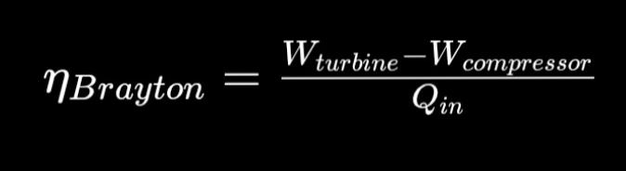
For the integrated system, the overall efficiency is defined as:


Where W_total represents the combined net work output from both cycles and Q_fuel is the total chemical energy input from methane combustion.

ENERGY BALANCE PRINCIPLES

The simulation applies the First Law of Thermodynamics for steady-flow systems:
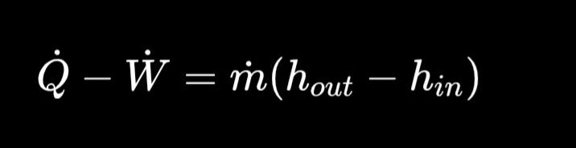

Energy balances are applied to each component under steady-state conditions, assuming negligible kinetic and potential energy changes.

METHODOLOGY
- Simulation Assumptions
The following assumptions were adopted to simplify the thermodynamic analysis:
- Steady-state and steady-flow operation.
- Negligible pressure drops in heat exchangers.
- No heat losses to the surroundings.
- Negligible kinetic and potential energy effects.

IDEAL GAS ASSUMPTIONS
Air and combustion gases in the Brayton cycle are treated as ideal gases with constant specific heats. This assumption simplifies property evaluation while maintaining reasonable accuracy at moderate pressures and temperatures.

TURBINE EFFICIENCY MODELING
Real turbines and compressors deviate from ideal isentropic behavior. Isentropic efficiency is used to account for irreversibilities:
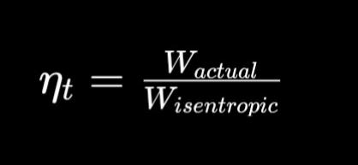
This efficiency directly influences the net work output and overall cycle performance.

PRESSURE AND TEMPERATURE INPUTS
The system is simulated using predefined pressure and temperature values consistent with industrial-scale power plants.

SYSTEM INPUTS
Boiler Pressure: [X MPa]
Condenser Pressure: [X MPa]
Turbine Efficiency: [X]
Compressor Pressure Ratio: [X]
Maximum Gas Temperature: [X K]

RESULTS
The simulation produced the following key performance results:
- Rankine Efficiency: [X %]
- Brayton Efficiency: [X %]
- Overall Efficiency: [X %]
- Turbine Power Output: [X kW]
- Fuel Energy Input: [X kJ/hr]
- Heating Energy Required: [X kJ]
- Methane Production Rate: [X kg/hr]
The Rankine cycle efficiency reflects the effectiveness of steam expansion and condensation processes, while the Brayton cycle efficiency is strongly influenced by turbine inlet temperature and pressure ratio. The overall efficiency demonstrates the benefit of integrating both cycles through heat recovery.

DISCUSSION
- Comparison of Rankine and Brayton Efficiency
The Brayton cycle typically exhibits higher efficiency than the Rankine cycle due to its higher operating temperature. However, the Rankine cycle effectively recovers waste heat, contributing additional power output without extra fuel consumption.
- Effect of Pressure Ratio
Increasing the compressor pressure ratio in the Brayton cycle improves thermal efficiency up to an optimal point. Beyond this point, compressor work increases significantly, reducing net output.
- Effect of Turbine Efficiency
Higher turbine efficiency directly increases power output and cycle efficiency. Small improvements in turbine efficiency can result in substantial gains in overall system performance.
- Integration Benefits
The integration of the Rankine and Brayton cycles significantly improves energy utilization. Waste heat recovery reduces fuel consumption and increases overall efficiency, making the system more sustainable and economically attractive.

LIMITATIONS
Despite its usefulness, the simulation has several limitations:
- Ideal gas assumption may introduce errors at high pressures.
- No heat losses were considered, leading to optimistic efficiency values.
- Simplified property calculations neglect real-fluid behavior and transient effects.

CONCLUSION
This laboratory project successfully demonstrated the thermodynamic modeling of an AD-HTC integrated Rankine–Brayton power plant using a digital twin approach. The results show that combined-cycle integration significantly enhances overall efficiency compared to standalone systems. Methane from anaerobic digestion provides a renewable fuel source, while hydrothermal carbonization improves biomass energy density. Although simplified assumptions were used, the simulation confirms the technical feasibility and efficiency advantages of AD-HTC systems for sustainable power generation. Future work should incorporate real-fluid properties, heat losses, and dynamic operating conditions for improved accuracy.

